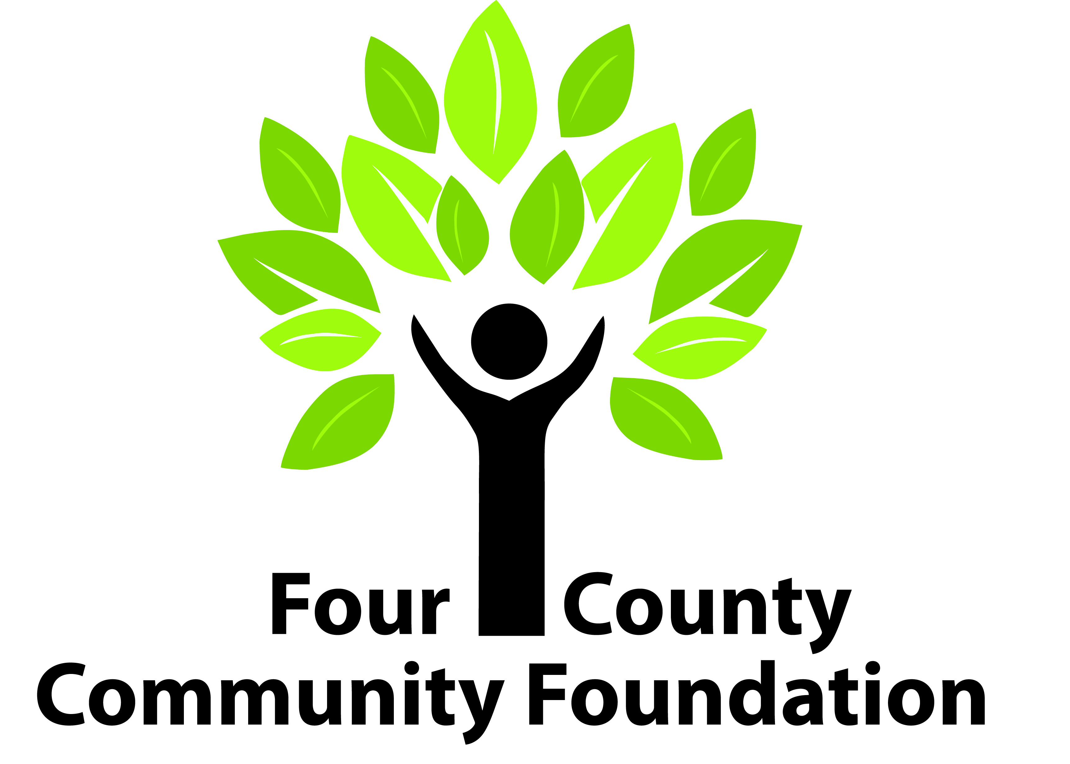

231 East St. Clair Street PO Box 539 Almont, MI 48003
Phone: 810.798.0909

FOUR COUNTY COMMUNITY FOUNDATION
Fund Request Form

Complete and submit this form to request the disbursement of grant dollars from your fund. This form must be signed by those authorized to act on behalf of the fund.

Fund Name: Date:

Grantee: (organization receiving the grant)
Grantee Address:
City: State: Zip:
Grantee Phone: Grantee email REQUIRED:
Description of Grant:
Amount of Grant: $ Expected date of project completion:
Fund Contact Person: Title:

The authorized official signing this request is verifying:
- this grant will not result in the donor, advisors, or related parties receiving any personal or material benefit, compensation or expense reimbursement, or exchange of goods or services
- this grant is not the fulfillment of a pledge made to any organization

_____________________________________
Signature of Authorized Fund Official Printed Name & Title

_____________________________________
Signature of School Superintendent Printed Name & Title

