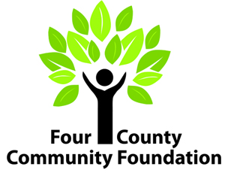
Russell W. Ligon Memorial Engineering Scholarship
Recommendation Form
Four County Community Foundation
PO Box 539, Almont, MI 48003
810-798-0909 www.4ccf.org

Candidate: Click here to enter text.

Completing this recommendation form:
The student named above is applying for a scholarship and has asked you to provide Four County Community Foundation information you feel would be helpful in reviewing his/her application. The information you furnish is important to us. You may be assured that it will be considered confidential. Please return this recommendation form directly to the applicant as soon as it is completed. Only applications that have the required recommendations on file will be considered.

Please complete the following:

Your name Click here to enter text.
Your relationship to applicant Click here to enter text.

How well do you know the applicant? Click here to enter text.

How long have you known the applicant? Click here to enter text.

Please respond to the following questions:
Why would you recommend this student for scholarship assistance? You may wish to compare this student to other college-bound or college students you have known, describing the qualities or characteristics you feel set this applicant apart from the rest.
Do you think the applicant has the ability, determination, and discipline to complete his/her educational objective to succeed as an engineer/computer scientist? Why or why not?

Signature___________________________________________ Date ___________________

