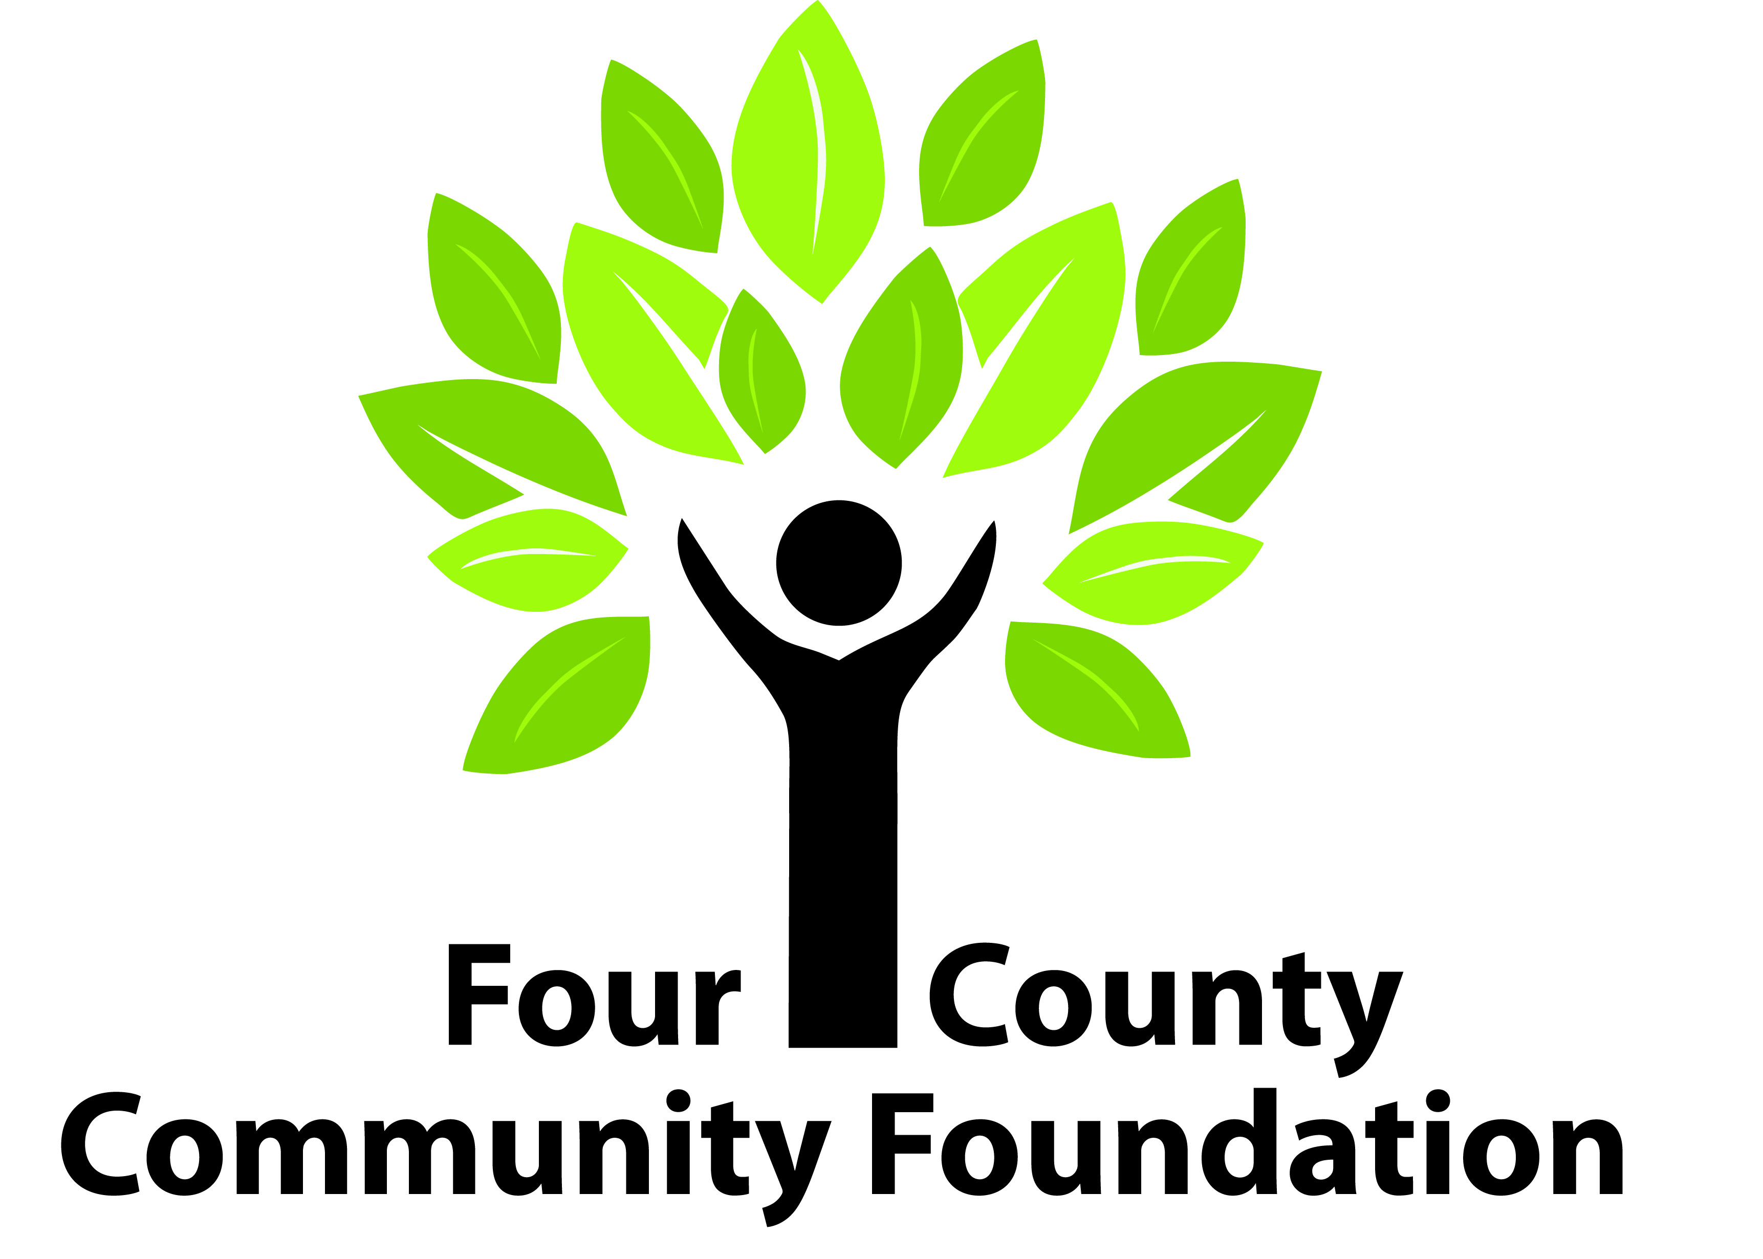

231 East St. Clair Street PO Box 539 Almont, MI 48003
Phone: 810.798.0909

FOUR COUNTY COMMUNITY FOUNDATIONS
Donor-Advised Fund Request

In order to request disbursement of grant money from your fund, you will need to complete and submit this form, signed by a person authorized to act on behalf of your organization or fund.

Fund Name: Date:

Grantee: (person or organization receiving the grant)
Grantee Address:
City: State: Zip:
Grantee Phone: Grantee email REQUIRED:
Description of Grant:
Amount of Grant: $ Effective Date:
Fund Contact Person: Title:

The authorized official signing this request is verifying:
- this grant will not result in the donor, advisors or related parties receiving any personal or material benefit, compensation or expense reimbursement, exchange of goods or services.
- this grant is not the fulfillment of a pledge made to any organization.

________________________________________
Signature of Authorized Fund Official Printed Name & Title

_________________________________________
Signature of Authorized School Official Printed Name & Title
(for scholarships only)

