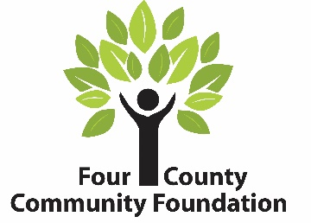
231 E St. Clair Street ▪ PO Box 539 ▪ Almont, MI 48003 ▪ (810) 798-0909

FOUR COUNTY COMMUNITY FOUNDATION
Fund Request Form

Fund Representatives: Download, complete, and submit (to: program@4ccf.org) this form to request the disbursement of grant dollars from your donor-advised, field of interest, or agency fund. The form must be signed by individuals authorized to act on behalf of the fund. Signatures of other interested parties (such as school superintendent, organization director, etc.) may also be required.

Fund Name: Date:

Grantee: (organization receiving the grant)
Grantee Address: City: State: Zip:
Grantee Phone: Grantee email REQUIRED:
Description of Grant:
Amount of Grant: $ Expected date of project completion:
Fund Contact Person: Title:

The authorized official signing this request is verifying:
- this grant will not result in the donor, advisors, or related parties receiving any personal or material benefit, compensation, or expense reimbursement, or exchange of goods or services
- this grant is not the fulfillment of a pledge made to any organization

_____________________________________
Signature of Authorized Fund Official Printed Name & Title

_____________________________________
Signature of other interested party Printed Name & Title
(school superintendent, organization director, etc.)

