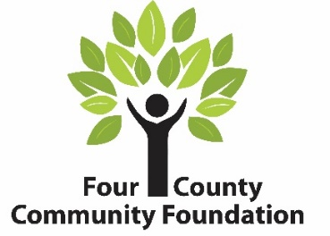
GRANT TANK
A Program of the Youth Advisory Committee (YAC)
Grant Application
Date Click here to enter text. | Amount Requested Click here to enter text.
Name of School Click here to enter text. | Contact Phone Click here to enter text.
Address Click here to enter text. | Email Click here to enter text.
Name of class/club/organization requesting the grant Click here to enter text.
Project/Program Title Click here to enter text.
Name(s) of student applicants Click here to enter text.
Grade(s) of student applicants Click here to enter text.
Name of Adult Advisor Click here to enter text.

- What does your group want to do? Why?
Click here to enter text.
- How will the project help your community? Who will it help? Are there advantages or benefits that will last a long time?
Click here to enter text.
- Who will be doing this project? Click here to enter text.
- When will this project take place and/or how long will the project or program last?
Click here to enter text.
- How much will this cost? If funding from other sources will be needed or used please list these below (include the amount you will receive and who you will receive it from). Use this area to show your budget for your project. A budget will show both the expected revenue and expenses. Attach a separate sheet if needed. Click here to enter text.
- How will you show that this program is successful? Click here to enter text.
(If funds are granted, you will be expected to provide photographs and a project summary at the end of your program).
- This form must be signed by the following:

Student Applicant(s)
Adult Advisor/Teacher
Superintendent

APPLICATIONS and VIDEOS must be received by midnight
January 1, April 1, July 1, October 1
Winners will be contacted within 30 days of the grant deadline.
Email all videos and applications to kdickens@4ccf.org and COPY mbrown@4ccf.org

